WELCOME TO
BURNFIELD MEDICAL PRACTICE

PRACTICE TEAM

Alongside our doctors we have a team of professionals with a mix of skills, knowledge and experience, striving to provide friendly, efficient, high quality, optimally tailored patient care

Practice Physiotherapist
Patients can book directly via reception with our Physiotherapist. We accept debit/credit cards. Our Physiotherapists are highly skilled and experienced for problems ranging from back, neck and shoulder pain, sciatica, leg and knee problems, minor and sports injuries, etc. Please ring reception on 01463 220077 for an appointment. Our Physiotherapist will also see private patients who are not registered with the practice. Fees are £65 for the first treatment and £50 thereafter.

Practice Nurse
Shelagh Kerr - provides chronic disease care and advice for conditions such as diabetes, asthma, heart disease and raised blood pressure. She performs cervical smears, dress wounds and gives contraception advice

Practice Manager – Jacqui Munro. Jacqui can be contacted through reception.

Reception Manager – Sophie Warne manages the reception and administrative team. Sophie ensures all administrative and reception tasks are carried out efficiently. Sophie is available for any questions or concerns, good and bad, you might have.

Reception

Our receptionists/administrators deal with a wide range of tasks including registering new patients, booking of appointments, dealing with any queries you may have, and all other daily administration tasks directly relating to patient care. Reception is a team of six who include Sophie Warne, Amy Younie, Nicole Wilson, Jane Haydock, Kiera Corson and Katrin Rough

Administrators

Julie Cadden, Leanne Macleod and Helen Macleod work in our upstairs office covering a wide range of general practice administrative tasks.

Health Care Assistants (HCA)

Our HCAs Christine Fyfe, Angela Spence and Liga Zommere work closely with the doctors and nurses. They undertake blood tests, chronic disease checks, blood pressures, heights/weights, wide injections, spirometry, ECGs, and assist during minor surgery, contraceptive implant and coil fitting/removal clinics. For annual chronic disease checks, you will first see the HCA and at a later date the practice nurse +/- doctor with your results. The data they record on our patient systems helps doctors and nurses to decide on your care.

APPOINTMENTS
Daily between 8 am and 6 pm, with a Wednesday late night until 7.30 pm.

Our receptionists are trained to allocate appointments and direct you to the most appropriate professional depending on your reason for contacting us. They may need to ask you some questions regarding your appointment to ensure you are directed appropriately. Answering them is optional but will help the efficiency of your appointment and being able to offer you the best patient care. Please be assured of our professional discretion and respect for patient confidentiality at all times.

We offer routine face to face, telephone appointments (at specific times) and on the day appointments. For housebound patients a home visit can be requested and a doctor will usually phone back first to confirm the need for a home visit and determine its priority.

HOW TO ORDER REPEAT PRESCRIPTIONS:

- online via www.patient-services.co.uk, or
- complete a form outside the practice and post into the post box marked ‘prescriptions’
- hand in/post a written list, OR the re-order form from to your last script with the desired items ticked off.
- ask chemist to take over your ordering

Please order repeat prescriptions in good time. If you have run out of medication, with less than 3 days’ supply left, please do not contact the practice, but first contact your chemist, who can issue an emergency supply of repeat prescriptions.

For e-mail confirmation of online prescription orders, please register as an online user and tick the relevant box.

To reduce reception workload, please nominate a chemist to which prescriptions should go.

Please allow 24 hours from the time of your request until the signed prescription sheet(s) will be ready for collection from our desk or after 24 hours we can send to your chosen pharmacy, please check with your pharmacy of their timeframe as each pharmacy varies.

We have no control over chemists’ speed of dispensing and you may wish to give chemist the “heads up” that prescriptions are on their way and when you wish to collect them. Chemists may also deliver medicines at your request.

Covid-19 Advice (NHS Inform)
All information regarding Coronavirus (COVID-19) can be found at https://www.nhsinform.scot/illnesses-and-conditions/infections-and-poisoning/coronavirus-covid-19 or be dialling 0800 028 2816.

OUT OF HOURS SERVICE (TEL: 111) – NHS 24: Emergency advice from 6.00pm – 8.00am Monday to Thursday and from 6.00 pm Friday to 8.00am Monday. NHS 24 triage calls to the most appropriate service. A detailed message of any contact is expected to reach the practice by 8.30 am the following morning.

LANGUAGE SERVICE:
Highly skilled telephone interpreters are available at any time for consultations in most languages, if required.

ACCESS FOR DISABLED
Our premises are fully accessible for wheelchair users and the disabled.

Non-NHS Services: Various services are provided privately which include HGV and PSV medicals, letters i.e. fit to fly) and insurance forms. These services are provided at the discretion of the doctors and a fee will be payable, please see our website.

Counsellors
We have experienced student counsellors from the University of the Highlands and Islands, who work under close supervision of their university mentors, and to whom doctors can refer patients. Reception will advise re days/times

Fourth Year students from Aberdeen University
As a training practice, we accommodate medical students several times a year, to enable them to learn about General Practice. We appreciate your help in their learning.

VISITING COMMUNITY STAFF & ACCESS TO RELATED SERVICES

We work with a range of health and social care colleagues, who are employed by other agencies, and can point patients to the most appropriate services. These include:

Community Midwives – Community midwives can be contacted from early pregnancy. Tel. 01463 704 342
District Nurses - Nursing treatment and advice to housebound patients. Tel. 01463 888 333
Social Workers – For care needs assessments and any social concerns: 01463 888 333, or 704 000 for duty social worker in a social care emergency.
Health Visitors – attend to families with children under 5 years old, advise on common infant (e.g. feeding) problems and developmental concerns, offering health information, advice and support. Based at Rowan House, Tel 01463 706700
Community Psychiatric Nurses – provide Mental Health Support (GP referral)
Macmillan Nurses – provide advice and support for cancer patients and their families/carers.
Podiatry – self referral forms available for NHS Podiatry service for foot and toe problems.
Smoking cessation – contact your local Pharmacist regards this service.
Drug and alcohol problems – self-refer by phone to Osprey House: 01463 716 888

Details of primary medical services in the area can be obtained from:
NHS National Services Scotland
Practitioner Services Division,
Bridgeview, 1 North Esplanade West
Aberdeen AB11 5QF (01224 358465)
www.psd.scot.nhs.uk/doctors/transfer_of_gp_health_records_faqs.html

COMPLAINTS/FEEDBACK PROCEDURE
We strive to work with patients to provide a high quality, friendly and efficient service. Should you be unhappy or dissatisfied with, or have concerns or suggestions for improvement regarding your care or the practice, please feel free to discuss this openly with the relevant professional, or should you feel unable, with the Practice Manager or one of the GP partners. Details of our complaints procedure can be obtained from reception, should you require more information or wish to make a written complaint. We also welcome any feedback regarding any positive experiences, so that we can continuously improve and build our service.

CPRD/SARD
This practice contributes anonymised data to the General Practice Research Database and Scottish Anonymised Research Database. If you would like more information please ask our practice staff for a leaflet

DATA PROTECTION ACT/CONFIDENTIALITY
The practice adheres to the data protection act of 1998 and we observe strict confidentiality. Details from your medical records cannot be released without your permission or court order, or it being deemed necessary due to a danger of serious harm to yourself or others. It is necessary to disclose information to other health professionals for the purpose of referrals or treatment. To optimise patient care, the practice has databases for various conditions, enabling us to review their medical care regularly.

YOUR RIGHTS AND RESPONSIBILITIES
As a patient you have the right to be treated with respect by the surgery staff, and similarly the responsibility to treat staff with respect. Please keep appointments and if unable, inform us with us good notice, to enable the re-allocation of the appointments to others who may need them. Violent or abusive behaviour from patients is fortunately rare in our practice, but such behaviour will result in removal from the practice list and may result in police involvement and legal action.

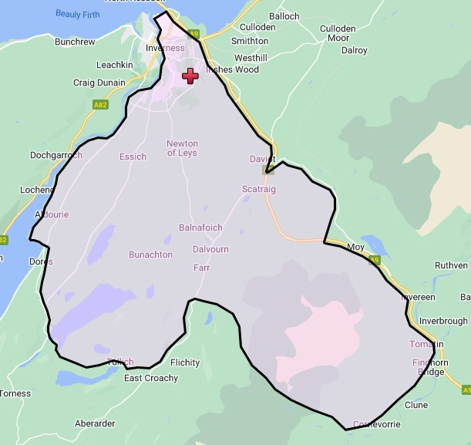
Fig 1 Practice Boundary

BURNFIELD MEDICAL PRACTICE
Harris Road
Inverness
IV2 3PF
Tel No. 01463 220077
Fax No. 01463 714588
www.burnfieldmedicalpractice.co.uk

OUR OPENING HOURS:
Monday – Friday 8.00 a.m. – 6.00 p.m.

Wednesdays until 7.30 pm

Dr Tilman von Delft (MBChB 1995)
MRCGP
Diploma of the Royal College of Obstetricians and Gynaecologists

Dr John McFadden (MBChB 1988)
MRCGP
Diploma in Sports Medicine
Diploma in Obstetrics

